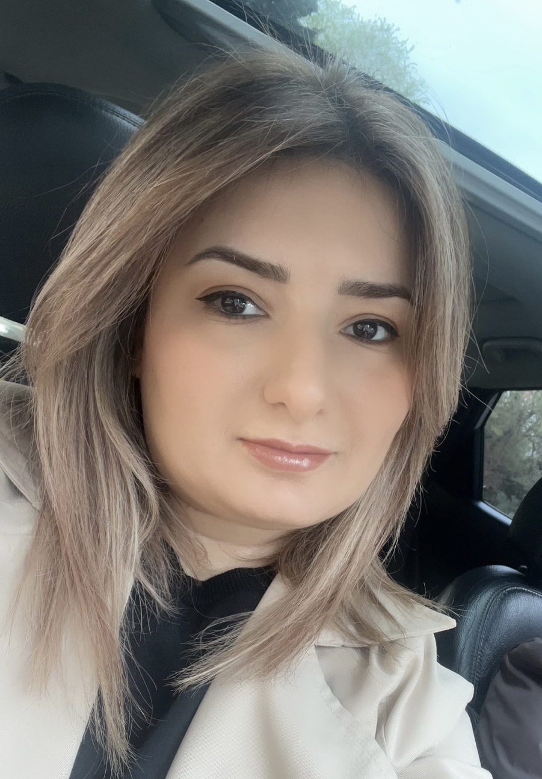
Gojayeva Shahla Yashar gizi
Hesen bey Zerdabi 202B, m.194
Baku, Azerbaijan
(99455) 975 75 07
sheylagodjayeva@hotmail.com

KEY QUALIFICATIONS:
• Responsible and organized
• Fast learner
• Good communication skills
• Creative thinking
• Attention to detail
• Ability to work independently
• Teamwork friendly

EDUCATION
The Academy of Public Administration under the President of the Republic of Azerbaijan
Administration managerial control
1999 – 2003
Secondary school 211
1989 – 1999

ADDITIONAL TRAINING
Theory and experience social work – June–July 2007

PROFESSIONAL EXPERIENCE
AGB Nielsen Media Research – Official License advertising agency
Position: Research and Operation Specialist (April 2004 – November 2017)
Responsibilities: Monitoring of TV channels; control of advertisement timing; preparation of report for sponsored program; regular control for editing and delivering of reports.
ARTIM Group of Companies
Project on conducting survey for Monitoring of Targeted Social Assistance programmed
Position: Operator - Collector (August 2007 – March 2009)
Responsibilities: Collect the information to computer for SPSS program

LANGUAGES
English – Good (Read, Speak, Write)
Russian – Fluent (Read, Speak, Write)
Azerbaijani – Native (Read, Speak, Write)
Turkish – Good (Read, Speak, Write)

COMPUTER SKILLS
Proficient in MS Office, Word, Excel, PowerPoint, email, Outlook Express, SPSS, TelePad

PERSONAL INFORMATION
Marital status: Single
Date of Birth: 05/08/1982
Place of Birth: Baku, Azerbaijan
Sex: Female
Nationality: Azerbaijani
Hobby: Internet, music, books
Driving license: B category

